**Lab Assignment 1**

|  |  |
| --- | --- |
| **Roll No.: A055** | **Name: Ibrahim Shaikh** |
| **Program: B. Tech**-**CSBS (2ND YEAR)** | **Date of Release:**   **19-July-2021** |
| **Batch:**  A / 1 | **Date of Submission: 25-July-2021** |

**PROBLEM STATEMENT:** A librarian wants to develop a library management application with following basic functionalities:

* + - 1. Enter the book details in the system.
      2. Display the complete list of the books.
      3. Search the book in the library by its name, if available then display no of copies of the book. If not then display message accordingly.
      4. Search the books in the library by Author Name, display all the books of the same author with number of copies
      5. Sort the list of books by its name.

Books are described by following attributes

* + 1. Name of the book
    2. Author of the book
    3. Price of the book
    4. No. of copies

**Concept to be implemented**: Structure and Arrays of structure in C++.

**CODE:**

#include <iostream>

#include <string.h>

using namespace std;

struct Book

{

    char name[20];

    char author[20];

    int price;

    int no;

}b[10];                                 //structure variable

int count;                               // Global Variable

int addbook()

    {

        int i;

        cout<<"\n\nEnter the No. of Books you want to add: ";

        cin>>count;

        for(i=0;i<count;i++)

        {

        cout<<"Enter the Book Name: ";

        cin>>b[i].name;                                       //used cin here because neither gets nor cin.getline working

        cout<<"Enter the Name of the Author: ";

        cin>>b[i].author;

        cout<<"Enter the Price of the Book: ";

        cin>>b[i].price;

        cout<<"Enter the No. of copies available: ";

        cin>>b[i].no;

        cout<<"\n\n";

        }

        cout<<"Details Saved....\n\n";

        return count;                                    // Returning 'count' value because it is needed in other func

    }

void display()

    {

        int i;

        for(i=0;i<count;i++)

        {

        cout<<"\nBook Name: "<<b[i].name;

        cout<<"\nBook Author: "<<b[i].author;

        cout<<"\nPrice: "<<b[i].price;

        cout<<"\nNo. of copies: "<<b[i].no;

        cout<<"\n\n";

        }

    }

void search_n()

    {

       int count, i, flag=0;

       char a[20];

       cout<<"\nEnter the Name of the book you want to search: ";

       cin>>a;

       for(i=0;i<count;i++)

       {

           if(strcmp(a,b[i].name)==0)           // Comparing strings if they are equal

           {

            flag=1;                             //changing flag value to 1 if they are equal for showing the appropriate output

            break;

            }

       }

       if(flag==1)

       {

            cout<<"\nEntered Book is Available\n";

            cout<<"The No. of books available is: "<<b[i].no;

       }

        else

            cout<<"\nThe given book is not found\n";

    }

void search_an()

    {

    int count, i, flag=0;

    char a[20];

    cout<<"\nEnter the Name of the Author you want to search: ";

    cin>>a;

    for(int i=0;i<count;i++)

       {

           if(strcmp(a,b[i].author)==0)

           {

            flag=1;

            break;

            }

       }

       if(flag==1)

       {

            cout<<"\nEntered Author's Books are Available\n";

            cout<<"The books available are: "<<b[i].name<<"\n";

       }

       else

            cout<<"The given Author's Books are not found\n\n";

    }

void sort()

    {

    char temp[20];               //Sorting using a Temp Variable (Bubble Sort)

    for (int i = 1; i < count; i++)

    {

        for(int j = 1; j < count ; j++)

        {

            if(strcmp(b[j-1].name,b[j].name)>0)

            {

                strcpy(temp, b[j-1].name);

                strcpy(b[j-1].name, b[j].name);

                strcpy(b[j].name, temp);

            }

        }

    }

     cout<<"\nNames Sorted in Alphabetical Order : \n";

        for(int i=0; i<count; i++)

        {

                cout<<"\n"<<b[i].name<<"\n";

        }

    }

int main()

{

    int opt;

    while(opt=!0)                 //while loop for keeping on taking the input until user manually exits be pressing '0' when asked

    {

    cout<<"LIBRARY MANAGEMENT APPLICATION\n\nMENU\n";

    cout<<"1. Add the book details\n";

    cout<<"2. Display the list of the books\n";

    cout<<"3. Search the book by its name\n";

    cout<<"4. Search the books by Author Name\n";

    cout<<"5. Sort the list of books by its name\n";

    cout<<"0. Exit the Menu\n";

    cout<<"\nPlease enter the required option: ";

    cin>>opt;

    switch(opt)              // Switch case for choosing the input of the user

    {

        case 1: addbook();

                break;

        case 2: display();

                break;

        case 3: search_n();

                break;

        case 4: search_an();

                break;

        case 5: sort();

                break;

        case 0: cout<<"Exiting the MENU....\n";

                exit(0);

        default: cout<<"You have entered a WRONG INPUT....try again\n\n";  // For Inputs other than the above cases

    }

    }

}

**OUTPUT:**

**Adding Book Details**: 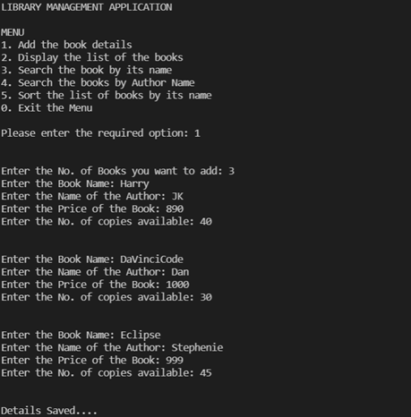

**Displaying:**

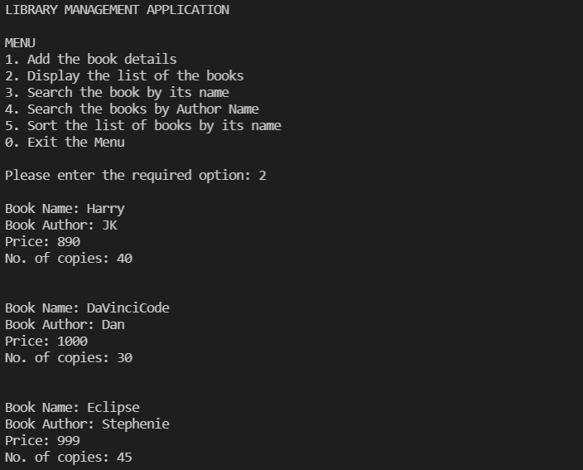

**Sorting:**

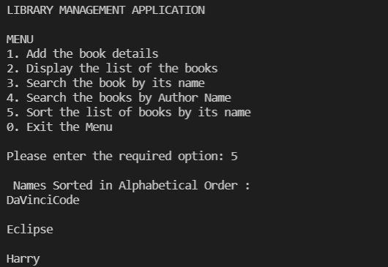

**Searching:**

**Book:**

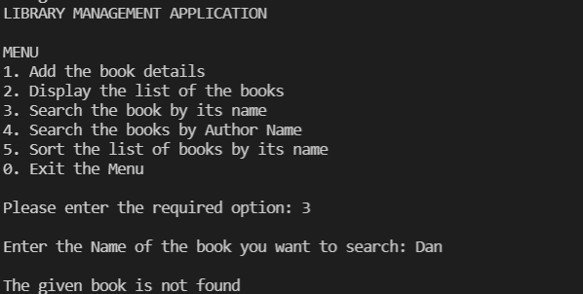

**Author:**

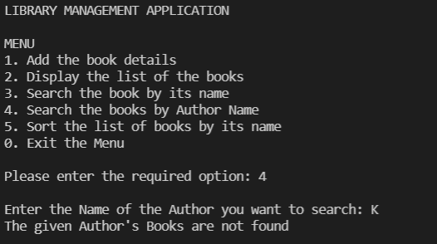

**LINK FOR THE CODE:** Done using OnlineGDB and VSCode.